Click2Cloud Inc.

Email: [contact@click2cloud.net](mailto:contact@click2cloud.net)

Document Version – V1.0

Requirement Document

Click2Cloud Cloud Monitoring Tool

JAnuary 12, 2018

Contents

Login 4

Register 4

Top Navigation 5

1. Cost Controller 6

1. Cost Allocation: 6

2. Budget Management 6

2. Optimizer 6

a) Sizing Threshold Manager 6

b) Predictive Analysis 6

c) Recommendation 6

3. Portability 7

a) Porting Your Deployment - Cost Analysis 7

b) Porting Your Deployment - Instance Type Mapping 7

4. Reports 7

1. Cost Comparison Report 7

2. Trend Analysis 8

3. RI Comparison 8

5. Setting 9

1. All Notification List 9

2. Notification Manager 9

3. Cloud Account Management 9

Dashboard 9

1. Cost by Cloud Provider 9

2. Usage by Cloud Services 9

3. Reserved Instance Purchase Impact by Services 9

Cost Controller 10

1. Cost Allocation 10

All Cost Allocation Model List 10

Creating Cost Allocation Model (Cost Allocation Management) 10

2. Budget 14

Optimizer 14

1. Recommendation/Optimizer 14

Sizing Thresholds Manager 15

2. Predictive Analysis 16

Portability 18

1.Porting Your Deployment – Cost Analysis 18

2. Porting Your Deployment - Instance Types Mapping 19

Reports 20

1. Cost Comparison Reports 20

1. Cost Analysis 20

2. Annual Projected Cost by Services 21

Please see below screenshot for more details. 21

3. Cost vs Budget Over Time Report – Performance Improvement 22

4. Actual Cost Over Time 23

2. Reserved Instance Comparison 23

1. Reserve Instance Purchase Impact by Services 23

2. Reserve Instance vs on demand Cost Comparison 24

3. Trend Analysis 25

1. Resource Usage by Cloud Provider 25

2. Resource Usage Over Time 26

Setting 27

1. Notification Management 27

2. All Notification List 35

3. Cloud Account Management 35

# Login

The login page is the first page that users see in the Cloud Monitoring application.

It provides two text fields - one for entering a login name and one for entering a password. If either of the text fields is left blank it is an error that must be reported to the user. If both fields are filled in but there is no record of the user name or the password is incorrect that must also be reported to the user.

After entering correct Login name and Password, click on ‘Login’ button to sign in. After successful login, user will redirect to the ‘Dashboard’ Page of Cloud Monitoring Application.

Users that have not yet registered cannot log in. They must first register by clicking on the   
‘No account yet? Register’ command button.

Please see below screenshot for more details.

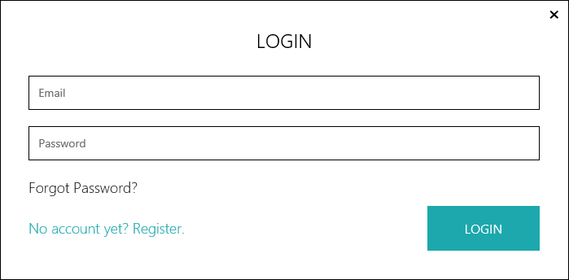

# Register

User can register themselves by creating an account in Cloud Monitoring Application by providing below details.

It includes First Name, Last Name, Company Name, Work Email, Phone Number, Password, Cloud Platforms, Amount spend.

Cloud Platforms: User needs to select Cloud that he wants to monitor. He can select multiple Clouds.

Amount Spend: User needs to select the amount. It has several options like Annual Cloud Spend(USD), Under 250k, Between 250k and 500k, Between 1M and 3M, etc.

Please see below screenshot for more details.

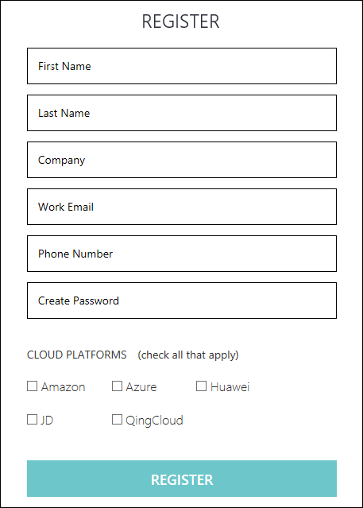

# Top Navigation

The Cloud Monitoring Application menu bar contains the following options:

1. Cost Controller
2. Optimizer
3. Portability
4. Reports
5. Setting

Please see below screenshot for more details.



## 1. Cost Controller

Cost controller contains two sub menus which are used for creating Models and managing budget:

### 1. Cost Allocation:

Create cost models which is used for filtering in cost analysis report.

### 2. Budget Management

Annual budget allocation which is further divided into Month.

Please see below screenshot for more details.

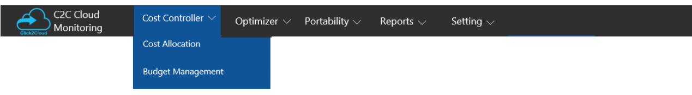

## 2. Optimizer

##### Optimizer focus on identifying opportunities for savings and improved efficiency.  This can be achieved through rightsizing undersized or over-sized instances, addressing inefficiencies. It contains three sub menu options:

### Sizing Threshold Manager

It sets thresholds for sizing recommendations. These recommendations are calculated using a complex algorithm to provide best sizing recommendations. User can also manually adjust threshold sizing recommendations from here.

### Predictive Analysis

Predictive analysis for future cost and usage based on user historical data of cost and usage trend.

### Recommendation

Recommendation advise user to change instance types based on their past utilization and cost.

Please see below screenshot for more details.

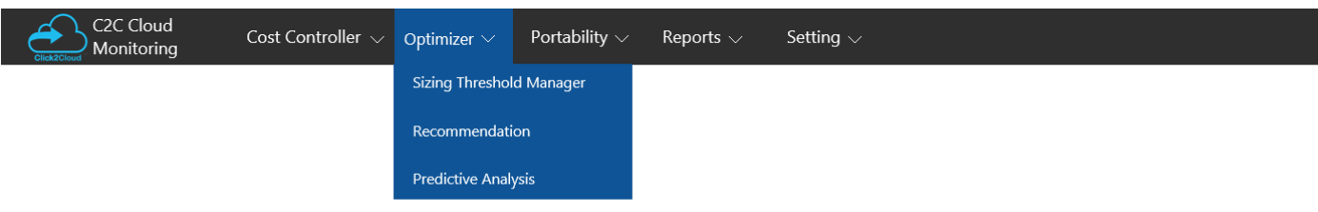

## 3. Portability

Portability contains two sub menus:

### Porting Your Deployment - Cost Analysis

This allows user to check potential costs, if user wants to port their deployment to a different Cloud provider.

### Porting Your Deployment - Instance Type Mapping

This report will be used, if user wants to see the detailed mapping of instance type deployment to a different Cloud provider.

Please see below screenshot for more details.

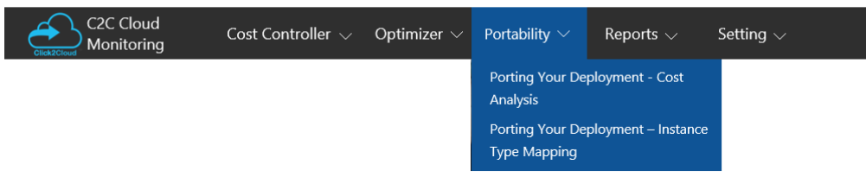

## 4. Reports

Reports contains three sub menus:

### 1. Cost Comparison Report

It has collections of reports where user can see consumption, expenses, projection, usage of resources across all accounts of registered Clouds.

#### Cost Analysis

The Cost Analysis report provides insight into user Cloud consumption and expenditure during a selected time frame along with the filtering by Model, Cloud Providers and Account.

#### Annual projection cost by Services

The Annual Projected Cost report provides a forecast of overall projected costs for the next 12 months.

#### Cost vs Budget Over Time Report - Performance Improvement

User can view analysis for user decided budget in budget management and what cost they spend for specific time span along with the total cost budget summary.

#### Actual Cost Over Time

This report displays spend cost over time, to allow user to observe trends and detect irregularities in user deployment.

Please see below screenshot for more details.

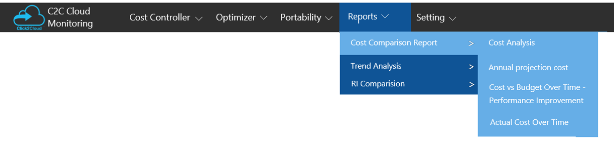

### 2. Trend Analysis

Trend Analysis report provides an operational analysis to understand usage patterns. It contains two sub menus:

#### 1. Resource Usage by Cloud Provider

This report will show the total usage of different Cloud providers by services over a specified time range.

#### 2. Resource Usage over Time

This report will show the resource usage by specified date range for each service according to filter criteria for usage statistics.

Please see below screenshot for more details

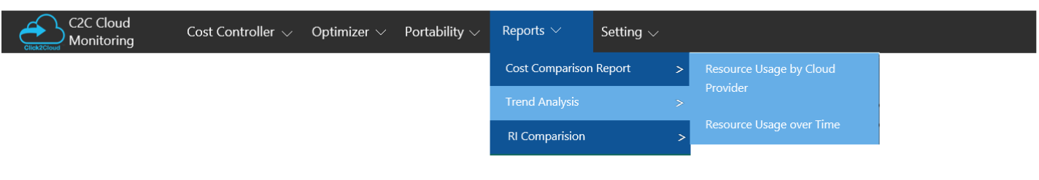

### 3. RI Comparison

#### 1.Reserved Instance Purchase Impact by services

It allows user to simulate reserved instance cost versus on-demand cost by **services** to assist user in making better purchasing decisions.

#### 2.Reserved Instance vs on demand Cost Comparison

It allows user to simulate reserved instance cost versus on-demand cost over **time** to assist user in making better purchasing decisions.

Please see below screenshot for more details

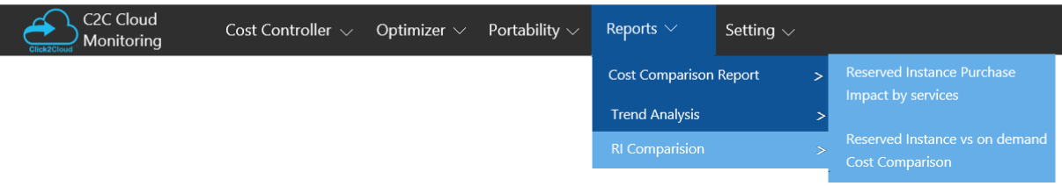

## 5. Setting

Setting include notification management and Cloud account management for Cloud provider subscription. It includes three sub menus.

### 1. All Notification List

Notification include list of all notification created by Cloud Monitoring Tool.

### 2. Notification Manager

In this, user can manage notification alerts when and how user should be notified.

### 3. Cloud Account Management

Here user can manage Cloud account subscription according to Cloud provider for further monitoring.

Please see below screenshot for more details

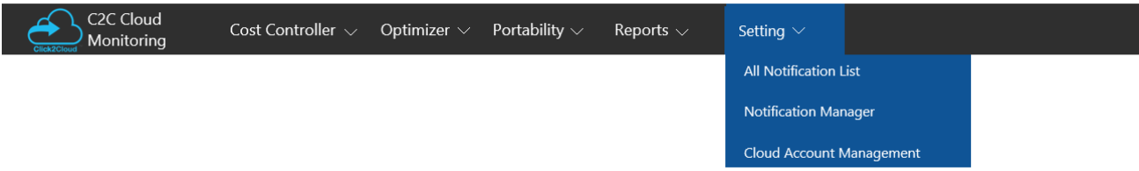

# Dashboard

Dashboard provide a view of report available to users in Cloud Monitoring. Dashboard is made up of widgets. Each widget is a report. The Summary dashboard displays reports for Cost, Usage and Optimizer.

## 1. Cost by Cloud Provider

This widget will show the **cost** of all registered Cloud provider for last 30 days. User can change the duration and widget will show the cost accordingly.

## 2. Usage by Cloud Services

This widget will show the **usage** of all registered Cloud provider for last 30 days. User can change the service and widget will show the usage according to services.

## 3. Reserved Instance Purchase Impact by Services

This widget will show **comparison** for RI cost and OnDemand cost for last 30 days by services. User can change the Cloud provider, widget will show the cost according to Cloud provider.

Please see below screenshot for details

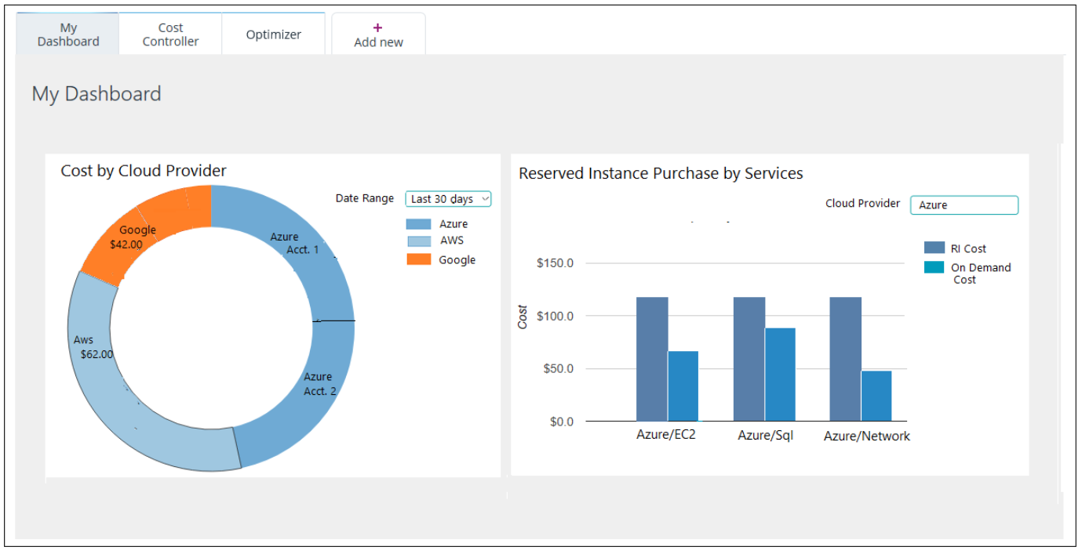

# Cost Controller

## 1. Cost Allocation

In this section, user can create cost allocation models for different views of cost distribution. It will be helpful for cost analysis report.

### All Cost Allocation Model List

It will show the list of all custom models. Here user can add, update and delete models.

Please see below screenshot for more details

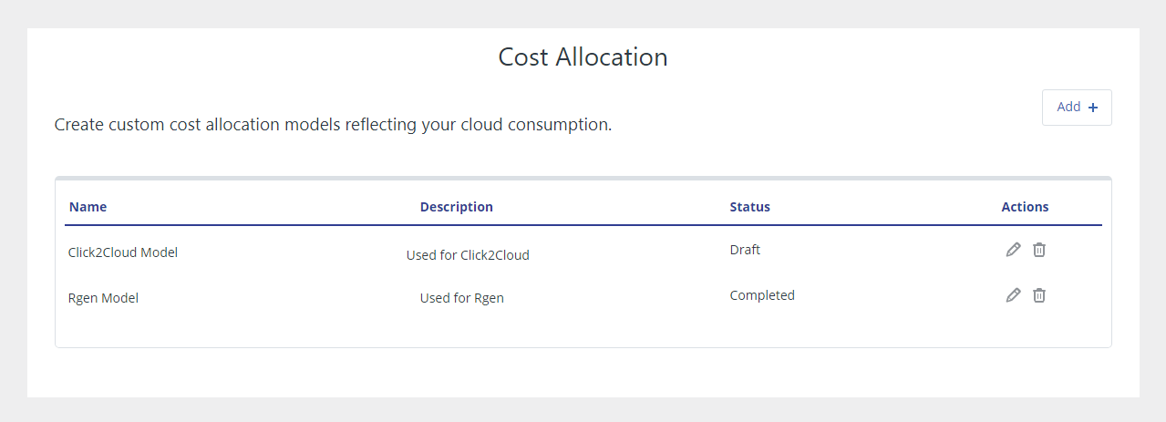

### Creating Cost Allocation Model (Cost Allocation Management)

To create cost allocation model first create model by giving name and description.

Please see below screenshot for more details

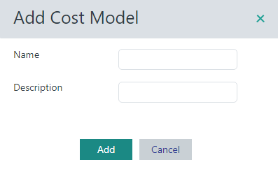

There are five tabs in the Cost Allocation Model: Accounts, Categorization,Uncategorized Resources, AWS Reserved Instances and Summary.

* **Accounts**: Select the account to include in the cost allocation model. This can be a combination of consolidated and/or standalone accounts. User can also set all existing and future accounts to be displayed on this report.

Please see below screenshot for more details.

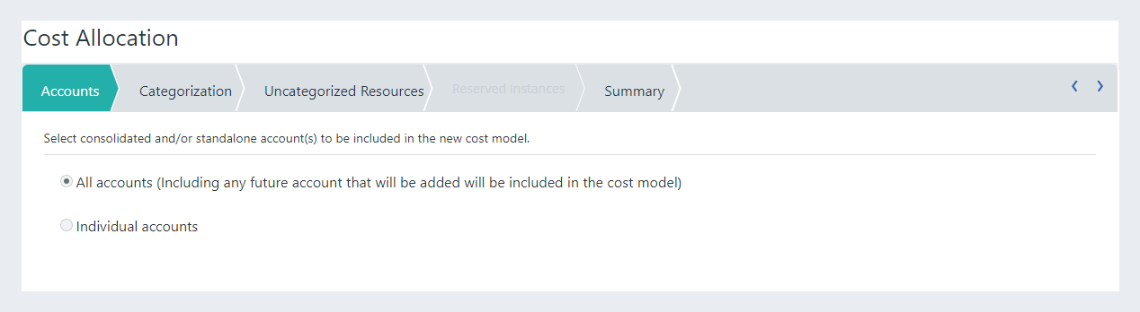

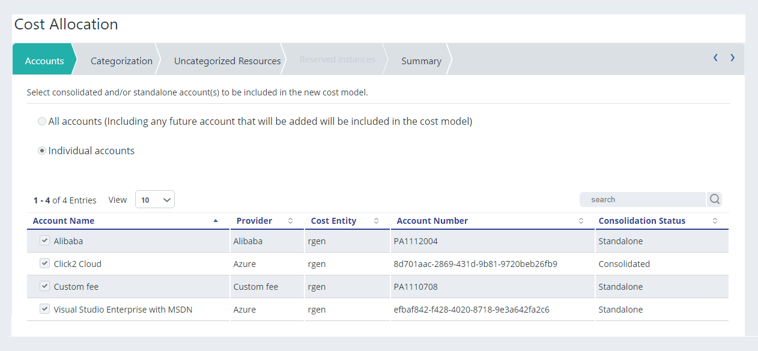

* **Categorization:** Categories are groups of tags or metadata. User can select multiple categories.

Please see below screenshot for more details.

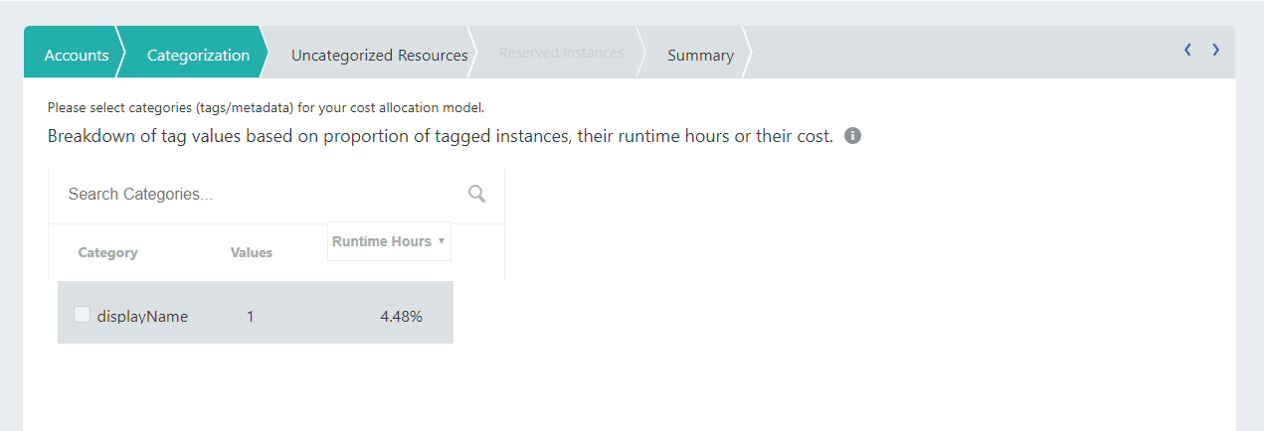

* **Uncategorized Resources:** There are a few types of uncategorized resources:

1. For AWS, untagged EC2/EBS and RDS instances and all other AWS Services.
2. For Azure, untagged of all Azure services.

Use this section to create allocation rules for uncategorized resources.

Please see below screenshot for more details.

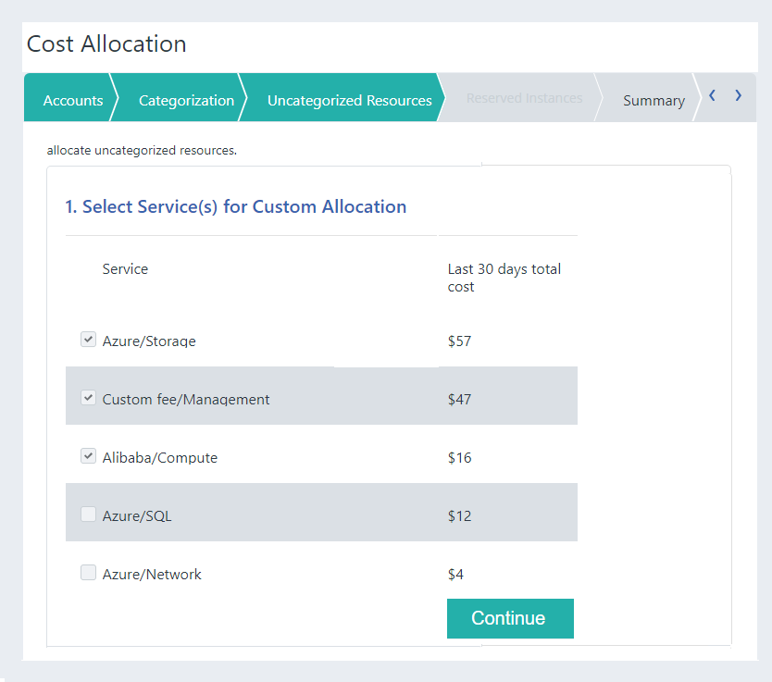

* **AWS Reserved Instances:** Create rules to assign reserved instances to selected categories.
* **Summary:** Review the details of the cost model. Save as a draft or Save and Activate.

Please see below screenshot for more details.

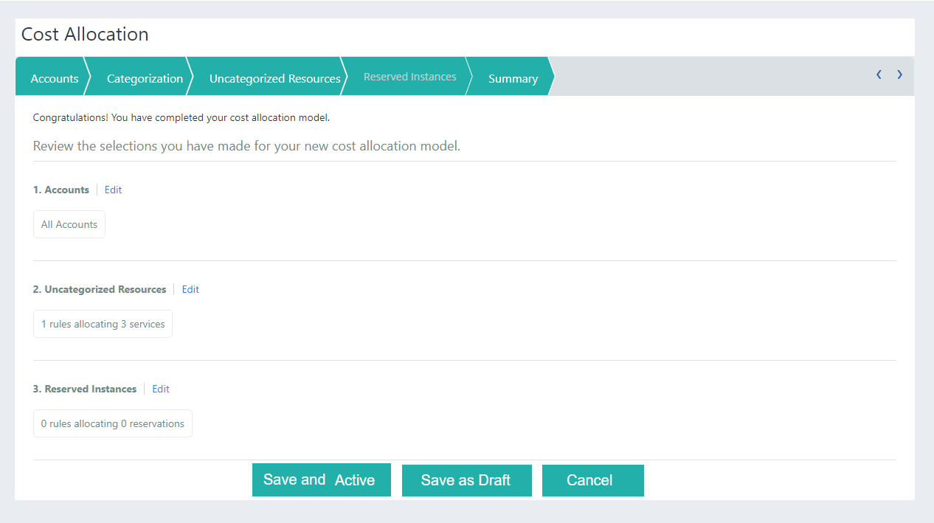

## 2. Budget

Setting up budgets and budget-based notifications enable Cloud monitoring customers to improve their Cloud governance and facilitate better Cloud accountability. User can manage annual budget by providing months slots.

Please see below screenshot for more details.

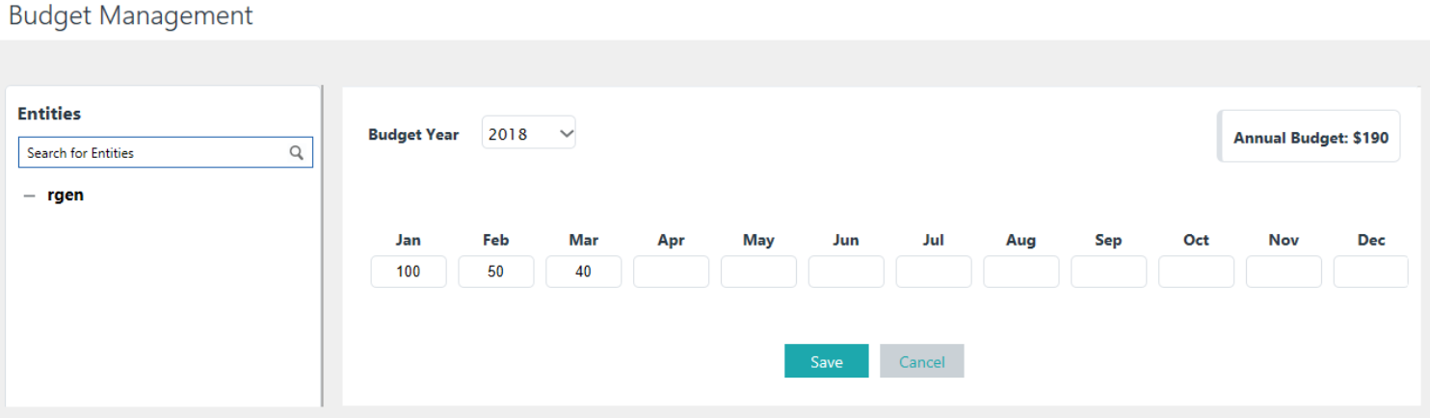

# Optimizer

## 1. Recommendation/Optimizer

Optimization reports focus on identifying opportunities for savings and improved efficiency. This can be achieved through rightsizing undersized or over-sized instances, addressing inefficiencies.

This report provides a list of **underutilized** instances that are candidates for downsizing. The recommendations are based on the usage and performance data of selected date range. Within each recommendation user can view complete details and performance metrics of the instance. This can be achieved by Machine Learning.

Recommendations report can be filter by Cloud Provider, Service, Account Name, Region, Instance Type, Platform, State, Date Range.

* Cloud Provider (mandatory): Select the Cloud provider to which the assets and expenses are associated.
* Model (mandatory): The model set in cost allocation.
* Service (mandatory): Select a service or show all services.
* Date Range(mandatory): Select a date range for which you want to view recommended instances.
* Account Name: Select the account or subscription name.
* Region: Select region the resource is hosted.
* Instance Type: Select the instance type or show all instance types.
* Platform (Linux/Unix/Widows): Select operating system.
* State: Select current state of the instance. It includes three states Activated, Terminated and Stopped.

It shows detailed compute sizing recommendations.  When relevant, recommendations will advise changing to newer generation instance types.

This section provides the overview of the recommendation which is based on CPU utilization and memory utilization. User can manually set thresholds for sizing recommendations from ‘Sizing Thresholds Manager’ (Navigate from Optimizer -> Sizing Thresholds Manager).

### Sizing Thresholds Manager

It sets thresholds for sizing recommendations. These recommendations are calculated using a complex algorithm to best provide accurate sizing recommendations.

You can also manually adjust threshold sizing recommendations from here. In Sizing Threshold Manager, adjust the following threshold as desired:

* Average CPU %
* Maximum CPU %
* Average Memory %
* Maximum Memory %

Click Apply to save changes. Changes apply immediately to all your recommendations.

Please see below screenshot for more details.

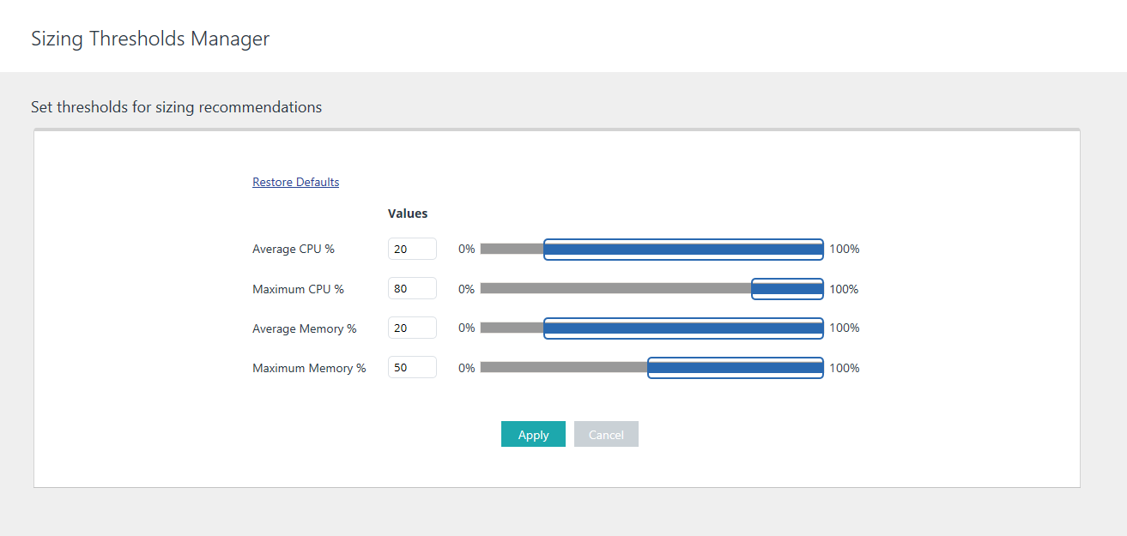

To restore default thresholds:

In Sizing Threshold Manager, click Restore Defaults.

Recommendation Details:

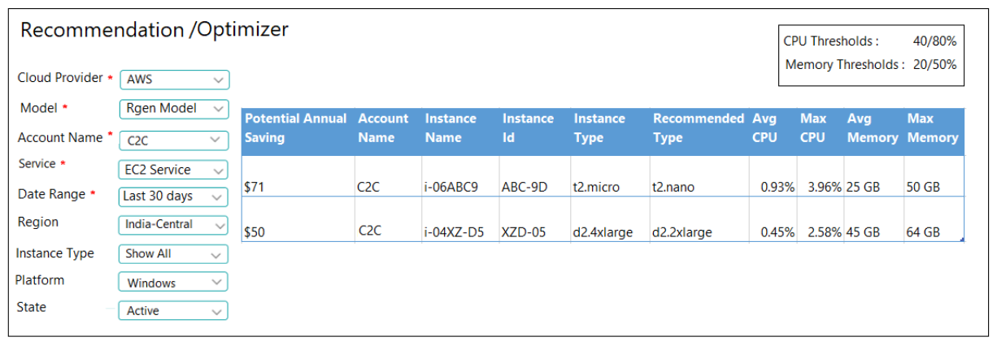

Potential Annual Savings: It shows the potential annual savings if we go from one instance to the recommended instance which is based on memory utilization and CPU utilization.

Avg CPU/Max CPU: This section provides the CPU utilization for the instance over the specified date range.

Avg Memory/Max Memory: This section provides information on the memory utilized (in GB).

Instance: It shows Instance details includes Instance Id, Instance Name, Instance Type.

Recommended Type: It displays recommended Instance Type as per your memory utilization and CPU utilization.

## 2. Predictive Analysis

Predictive Analysis is a form of advanced analytics that uses both new and historical data to forecast future activity, behaviour and trends. It uses many techniques from data mining, statistics, modelling, machine learning, and artificial intelligence to analyse current data to make predictions about future.

This report allows you to check potential costs of selected instance type for date range. It displays the cost comparison of the total cost from the selected date range, the projected cost till the user specified period, and the recommended instance type cost. It also shows the recommended instance type based on your usage.

This report can be filter by Cloud Provider, Account Name, Service, Instance Type, Date Range, Projected Date Range.

* Cloud Provider (mandatory): Select the Cloud provider to which the assets and expenses are associated.
* Account Name (mandatory): Select the account or subscription name.
* Service (mandatory): Select a service or show all services.
* Instance Type (mandatory): Select the instance type or show all instance types.
* Date Range (mandatory): Select a date range from which you want to compare the cost of selected instance.
* Region: Select region the resource is hosted.
* Projected Date Range (mandatory): Select a projected date range to view the projected cost.

Please see below screenshot for more details.

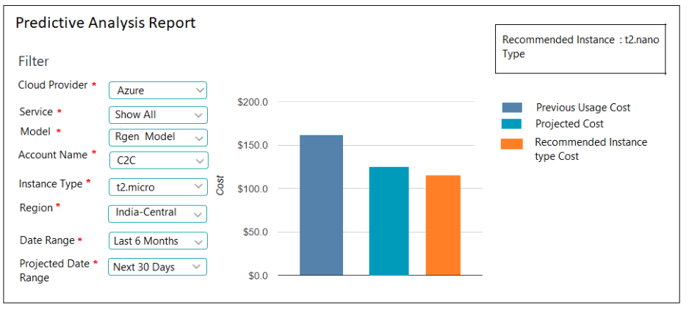

Previous Usage Cost: It shows the usage cost of instance type from selected date range.

Projected Cost: It is calculated based on previous usage cost. Projection is based on the cost monitored in the specific date range.

Recommended Instance Type: It displays recommended Instance Type as per your previous usage cost and projected cost.

Recommended Cost: It shows the recommended instance type cost.

# Portability

## 1.Porting Your Deployment – Cost Analysis

This Cost Analysis report allows user to check potential costs if user port the deployment to a different Cloud provider.

Use this report to:

1. Compare costs of different Clouds for your deployment.
2. Analyse where savings may be obtained in different Clouds based on various parameters.

This report can be filter by, Porting To, Porting From, Region Best Match, Instance Best Match, Account Name, Platform, State, Instance Type, Region.

* Porting To (mandatory): Select the Cloud you are considering porting your deployment to.
* Porting From (mandatory): Select the Cloud you are considering porting your deployment from.
* Region Best Match (mandatory): Select the option that best suits your region: By proximity, By Capacity or By Cost.
* Instance Best Match (mandatory): Select the option that best matches your instance: By ECU, By RAM, By Higher ECU, By Higher RAM.
* Account Name: Select the account or subscription name.
* Platform: Select operating system.
* State: Select current state of the instance. It includes three states Activated, Terminated and Stopped.
* Instance Type: Select an instance type or show all instance types.
* Region: Select region the resource is hosted.

Please see below screenshot for more details.

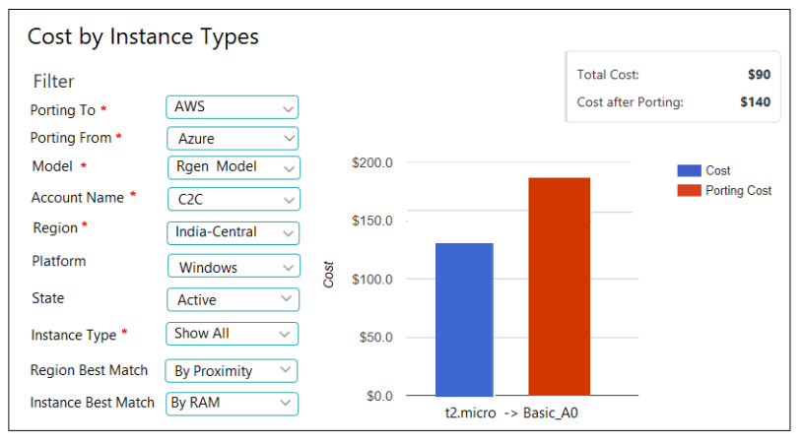It shows the Total Cost and Cost after porting to another Cloud by Instance Types for specified date range.

## 2. Porting Your Deployment - Instance Types Mapping

Use the Instance Types Mapping report to view the mapping of instance types between different Cloud providers.

Instance type mapping report can be filter by,

* Source (mandatory): Select the original Cloud provider.
* Target (mandatory): Select the Cloud provider the instance will be moved to.
* Instance Match By (mandatory): Select the option that best matches your instance: By ECU, By RAM, By Higher ECU, By Higher RAM
* Region Match (mandatory): Select the option that best matches your instance: By Proximity, By Capacity, By Cost
* Instance Type: Select the instance type.
* Region: Select region the resource is hosted.

Please see below screenshot for more details.

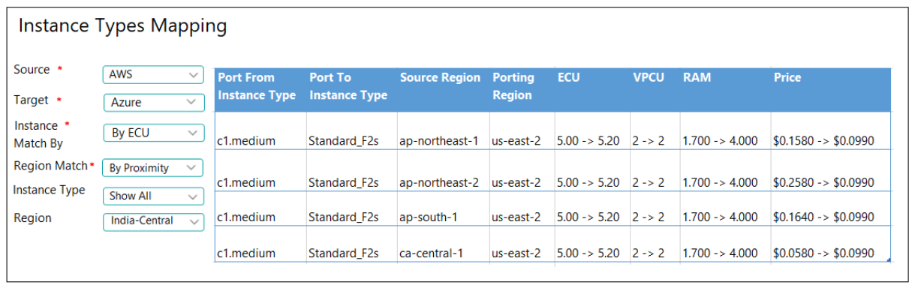

Instance Type Mapping Details:

Port from Instance Type: It shows the instance type of selected source Cloud.

To Instance Type: It shows the instance type of target Cloud.

Source Region: It shows the region of selected source Cloud.

Porting Region: It shows the region of selected target Cloud.

Price: It displays the cost of instances in both Clouds (source and target).

vCPU/ECU/RAM: It displays the vCPU, ECU and memory consumption of selected instance.

# Reports

## 1. Cost Comparison Reports

### 1. Cost Analysis

The Cost Analysis report provides insight into Cloud consumption and cost spend during a selected time frame across the Cloud providers. The model set in the Cost Allocation Manager are used in the Cost Analysis report.

This Cloud monitoring tool processes cost data (billing) and matches the data to the usage and tag data of user’s Cloud accounts. To match this data, it requires access to usage data.

If an account does not use a specific service will not have any costs of this service allocated to it. The costs accrued in that account remain in that account and are not calculated by the allocation models. For example, if user has five linked accounts and only three of them use storage services, the cost of storage services will only be allocated across tags in these three accounts.

Use Cost Analysis report to:

1. Display an aggregated view of your entire deployment for a specific time frame.
2. View costs by tag categories based on models created in the cost allocation.

Cost Analysis report can be filter by Cloud Provider, Model, Account Name, Date range.

* Cloud Provider (mandatory): Select the Cloud provider to which the assets and expenses are associated.
* Account Name (mandatory): Select the account or subscription name or show report for all accounts.
* Model (mandatory): The model set in cost allocation.
* Date Range (mandatory): Select a date range from which you want to view the cost across the Cloud providers.

Please see the screenshot for details.

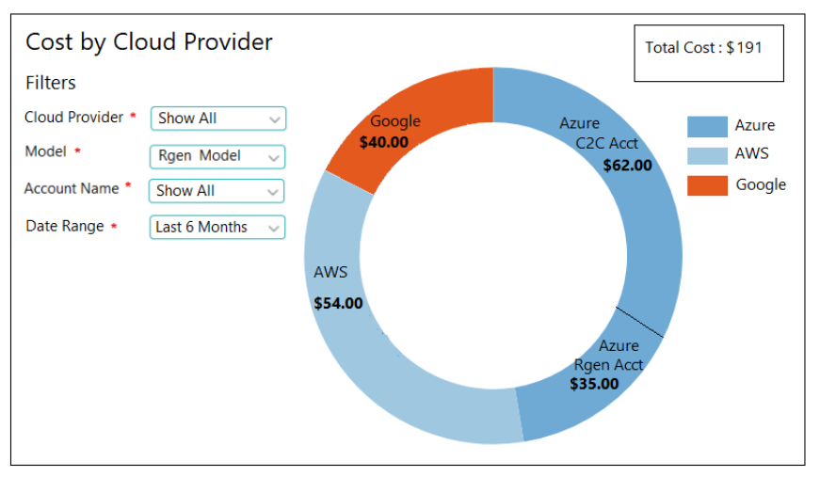

### 2. Annual Projected Cost by Services

The Annual Projected Cost report provides a forecast of overall projected costs for the next 12 months. It also displays the current annual projected cost summary at the top right of the report. The calculation based on the costs associated with last 30 days of usage. You can view annual projected costs based on previous spending trends. In Filter, select a specific Cloud provider to view projected cost as per services. Select a specific Cloud services for which to show results or select show all items in this group. Select a cost allocation model to view projected costs as per accounts.

* Cloud Provider (mandatory): Select the Cloud provider to which the assets and expenses are associated.
* Account Name (mandatory): Select the account or subscription name.
* Model (mandatory): The model set in cost allocation.
* Services (mandatory): Select a service or show all services to view annual projected cost.

Please see below screenshot for more details.

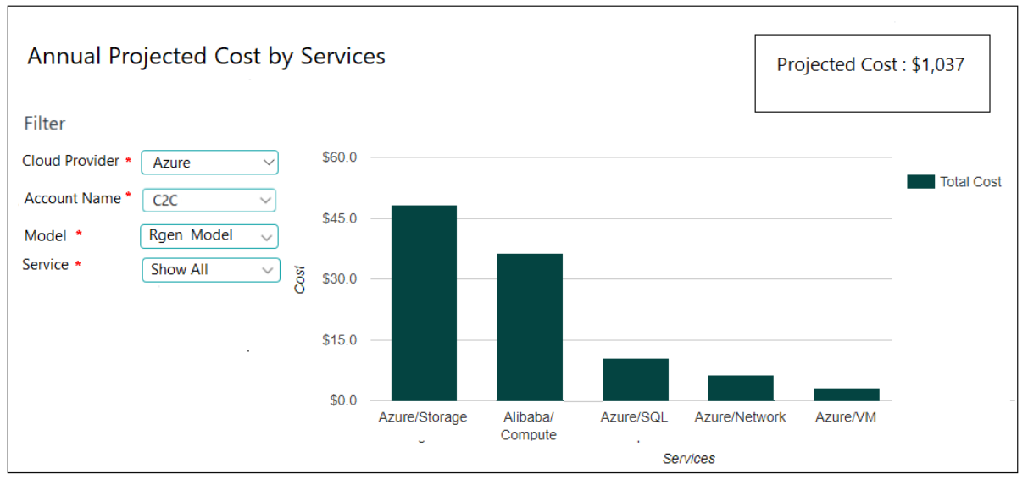

### 3. Cost vs Budget Over Time Report – Performance Improvement

This report shows the annual cost spent over the budget added as per month in the budget section. Navigate to Budget (Cost Controller -> Budget) and here user can enter an amount for each month’s budget. It also displays the annual accumulated cost and total budget summary at the top right of the report.

This report can be filter by Cloud Provider, Model, Account Name.

* Cloud Provider (mandatory): Select the Cloud provider to which the assets and expenses are associated.
* Account Name (mandatory): Select the account or subscription name.
* Model (mandatory): the model set in the cost allocation model.

Please see below screenshot for more detail.

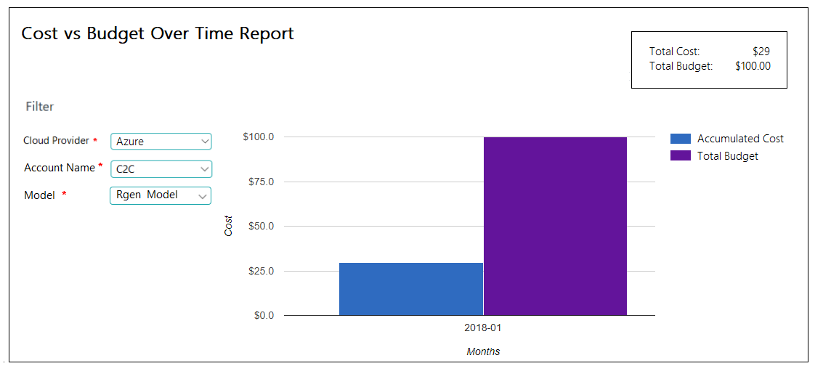

### 4. Actual Cost Over Time

The Actual Cost Over Time report displays spend over time to allow you to observe trends and detect irregularities in your deployment. This report includes main cost contributors such including ongoing costs and one-time Instance fees are being spent during a selected time frame. It also displays the total cost summary over specific timeframe at the top right of the report.

Use Actual Cost Over Time to:

1. See cost trends over time
2. Find irregularities in cost

This report can be filter by Cloud Provider, Model, Account Name, Date Range.

* Cloud Provider (mandatory): Select the Cloud provider to which the assets and expenses are associated.
* Account Name (mandatory): Select the account or subscription name.
* Model (mandatory): The model set in cost allocation.
* Date Range (mandatory): Select a date range from which you want to view the cost across the Cloud providers.

Please see below screenshot for more details.

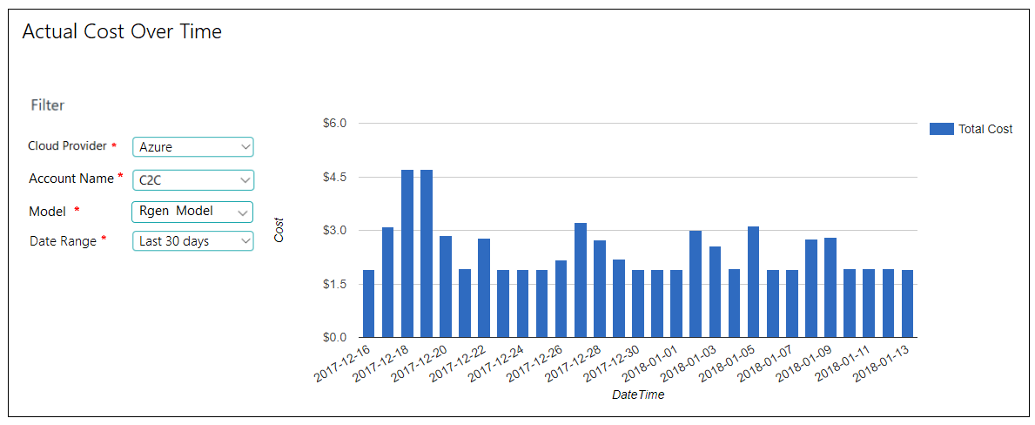

## 2. Reserved Instance Comparison

### 1. Reserve Instance Purchase Impact by Services

The Reserved Instance Purchase Impact report allows you to simulate reserved instance cost versus on-demand annual cost by services to assist you in making better purchasing decisions. Adjusting the filters such as Cloud Provider, Account Name, Service, Region, Instance Type, Term allows you to make informed decisions when considering RI purchases.

This can be filter by

* Cloud Provider (mandatory): Select the Cloud provider to which the assets and expenses are associated.
* Account Name (mandatory): Select the account or subscription name.
* Service: Select a service or show all services.
* Instance Type (mandatory): Select the instance type or show all instance types.
* Region (mandatory): Select region the resource is hosted
* Date Range (mandatory): Select a date range from which you want to compare the cost of selected instance.

Please see below screenshot for more details

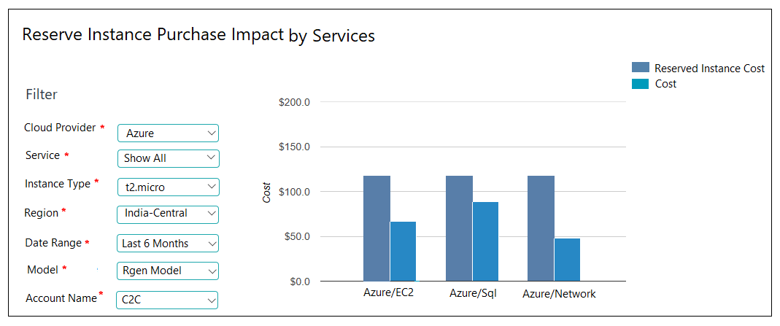

It shows the accumulated cost of Reserved Instance and on demand Instance by Services for annual term plan.

### 2. Reserve Instance vs on demand Cost Comparison

The Reserved Instance vs on demand cost comparison report allows you to simulate reserved instance cost versus on-demand cost over time to assist you in making better purchasing decisions. Adjusting the filters such as Cloud Provider, Account Name, Service, Region, Instance Type, Term allows you to make informed decisions when considering RI purchases.

This can be filter by

* Cloud Provider (mandatory): Select the Cloud provider to which the assets and expenses are associated.
* Account Name (mandatory): Select the account or subscription name.
* Service (mandatory): Select a service or show all services.
* Instance Type (mandatory): Select the instance type or show all instance types.
* Region (mandatory): Select region the resource is hosted
* Term (mandatory): Select one or three years.

Please see below screenshot for more detail.

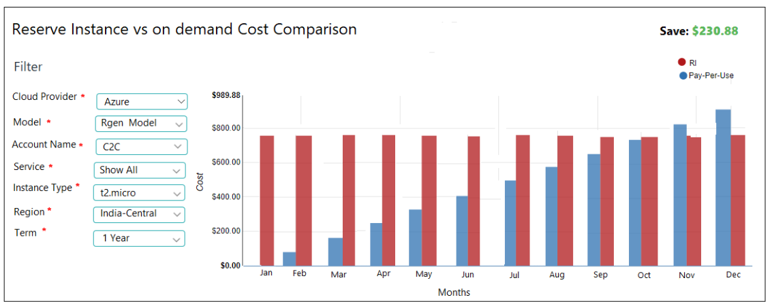

It shows the accumulated cost of Reserved Instance and on demand Instance by Month for annual year and by years for 3-year term plan.

## 3. Trend Analysis

### 1. Resource Usage by Cloud Provider

This report will show the total usage of different Cloud Providers by Services over a specified time range.

This can be filter by,

* Cloud Provider (mandatory): Select Cloud provider name or show all Cloud Providers.
* Service (mandatory): Select the service for Cloud.
* Date Range (mandatory): Select the Date range for which user wants to filter data.
* Region (mandatory): Select region if you want region specific data.
* Account Name (mandatory): Select the account or subscription name.
* Model (mandatory): The model set in cost allocation.

Please see below screenshot of Storage Service.

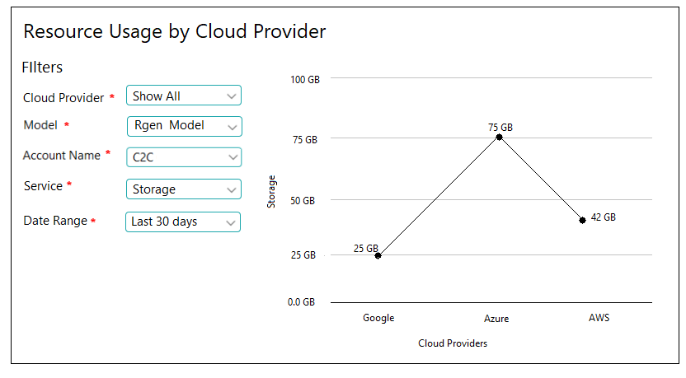

### 2. Resource Usage Over Time

This report will show the resource usage by specified date rage for each service.

This can be filter by,

* Cloud Provider (mandatory): Select Cloud provider name.
* Service (mandatory): Select the service for Cloud.
* Term (mandatory): Select the term period for which user wants to filter data.
* Region (mandatory): Select region if you want region specific data.
* Account: Select account name to show account specific data.
* Model (mandatory): The model set in cost allocation

Please see below screenshot for more details.

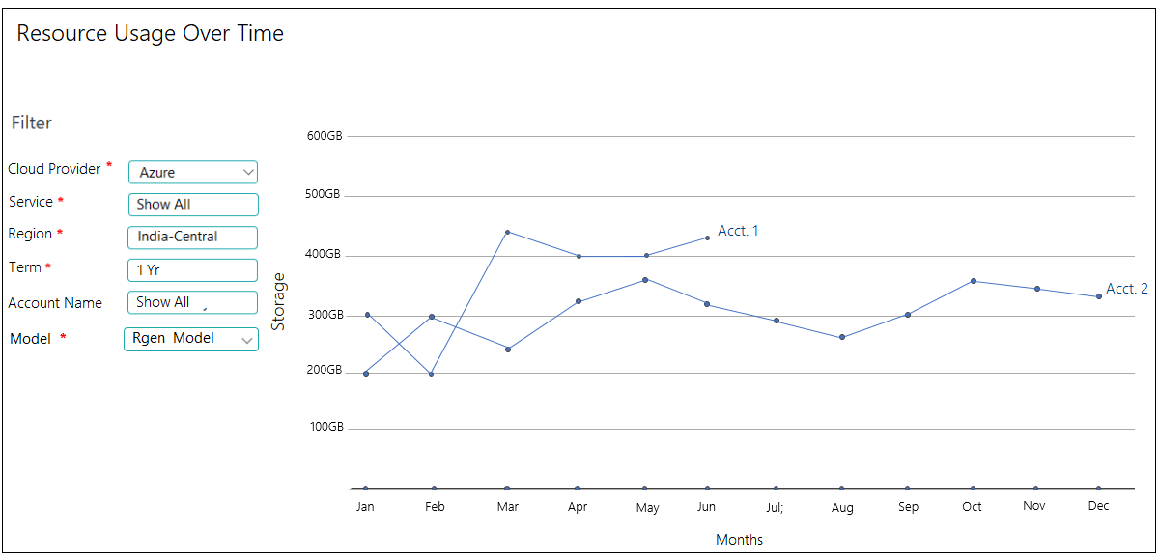

# Setting

## 1. Notification Management

Notification Management provides a single location for configuring and viewing notification. It can be filtered by Cost Controller, Asset Controller, RI Navigator

Cloud Monitoring Notification allows user, to be notified of unplanned changes or events in user Cloud accounts.

Working with Notification Management:

1. View notification
2. Activate notification definitions
3. Setting notification parameters and thresholds
4. Delete notification
5. View Notification

A list of notifications scheduled will be displayed.

Please see below screenshot for more details.

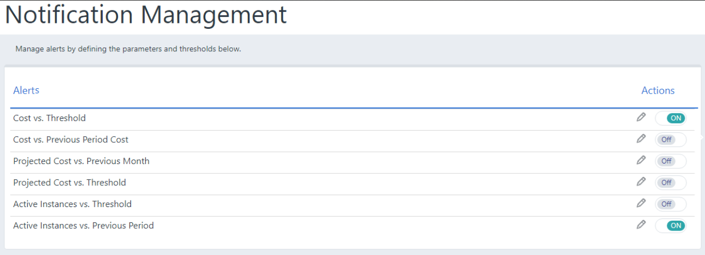

1. Activate Notification Definitions

User can activate or deactivate notification by using this wizard.

1. Setting Notification parameters and thresholds

With the help of this user can set the parameters or can create custom notification.

To create custom notification:

* Set the type of notification to receive alerts:
  + Daily
  + Weekly (notification is scheduled to be sent every Monday)
  + Monthly (notification is scheduled for the 1st of every month)
* In Apply To, set the:
  + Account
  + Service
* Check Send via Email, and select the recipient list to which the notification should be sent.
* To edit a recipient list, click on the link. See [recipient lists](https://support.cloudyn.com/hc/en-us/articles/210417005-How-to-Create-Recipient-Lists).

Please see below screenshot of Cost vs Thresholds Notification.

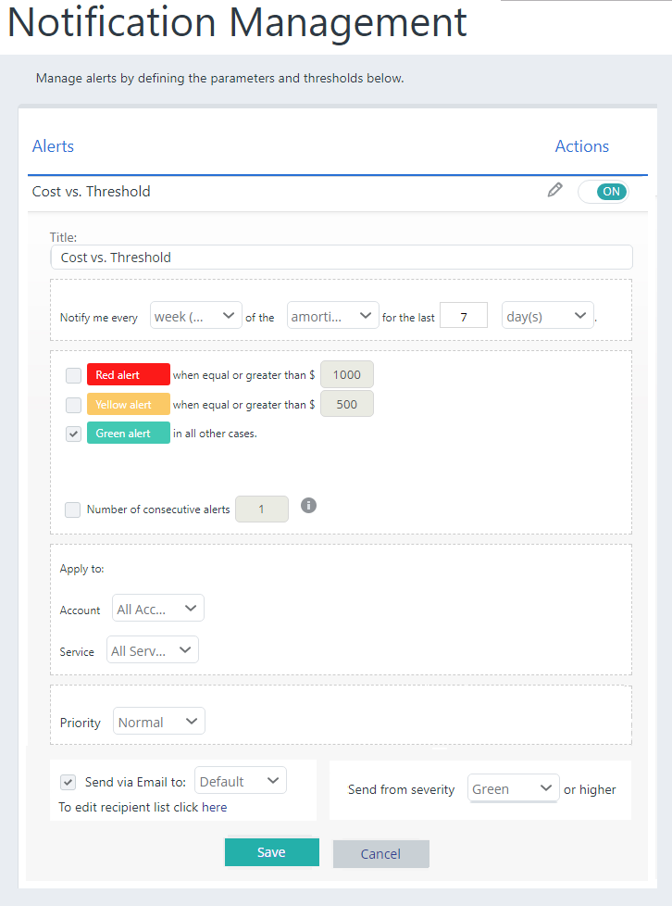

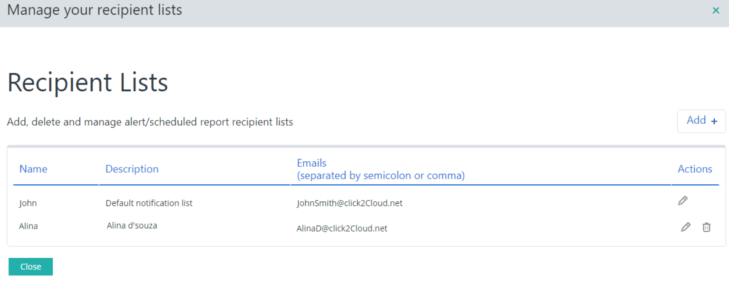

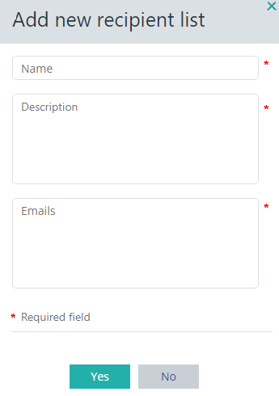

1. Delete Notification

Admin rights are required to delete notification.

Available Notification

* Projected Cost vs. Threshold

Please see the screenshot for more details.

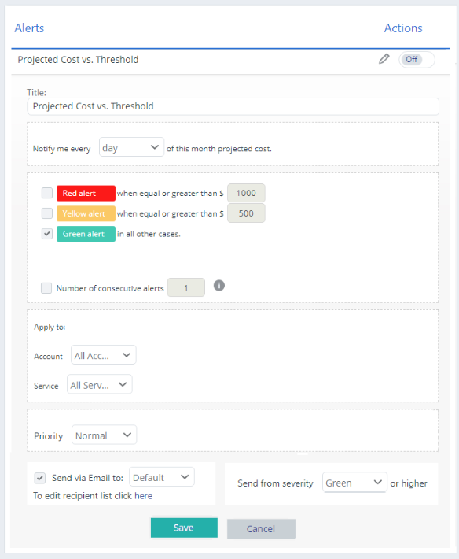

* Cost vs. Threshold
* Projected Cost vs. Previous Month

Please see the screenshot for more details.

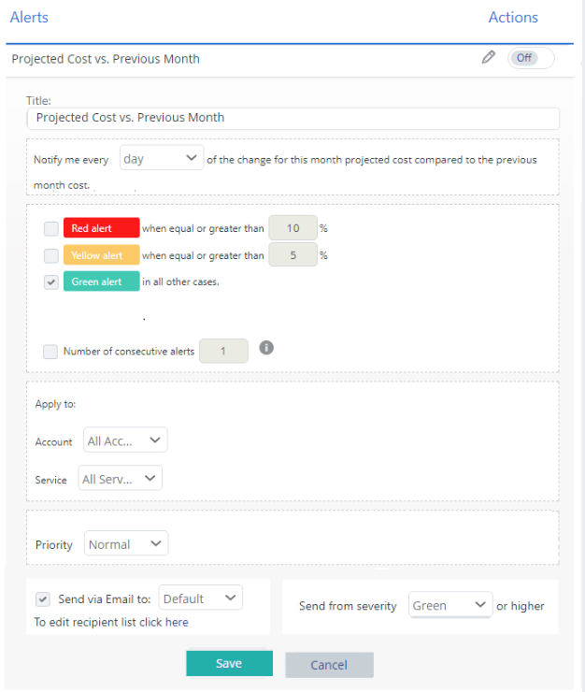

* Cost vs. Previous Period Cost

Please see the screenshot for more details.

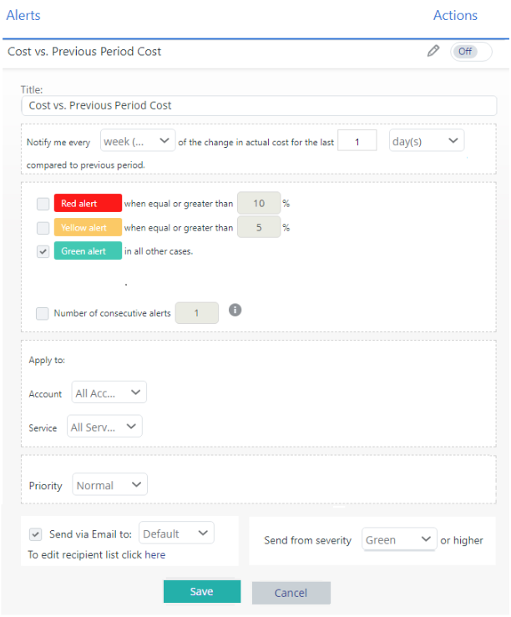

* Active Instances vs. Threshold

Please see the screenshot for more details.

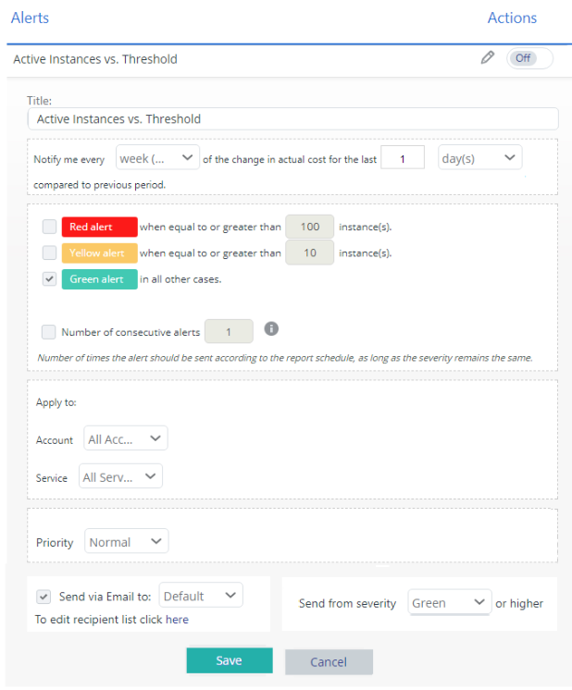

* Active Instances vs. Previous Period

Please see the screenshot for more details.

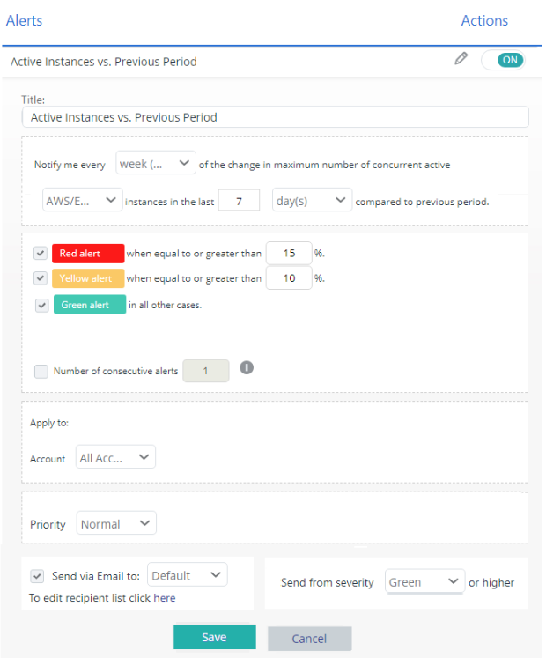

## 2. All Notification List

User can see all notification list and details including Title, Account Name, Service for which notification are active from user side.

## 3. Cloud Account Management

Here user can manage their different Cloud account’s subscription according to Cloud provider for further monitoring.

Below is the screenshot for adding account.

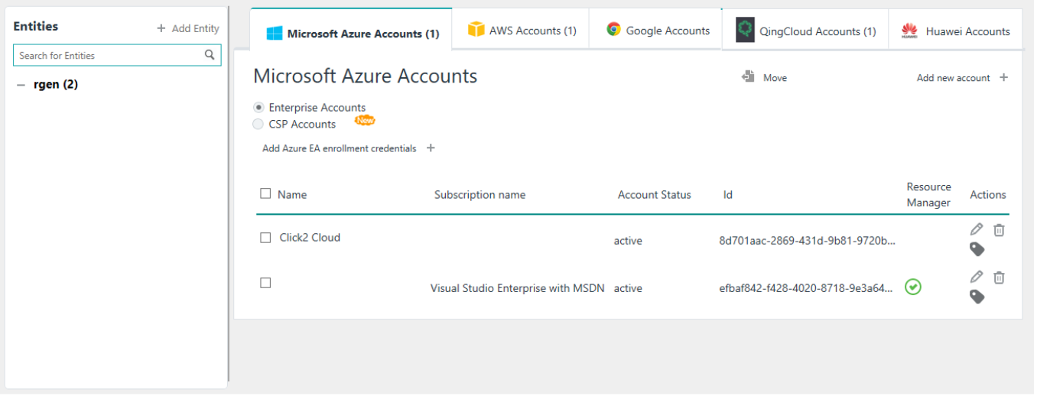

In Cloud Management section, user needs to create Entity for multiple Cloud Account’s.

To Add an entity:

Click on ‘Add Entity’ button on the top right corner of ‘Entities’ section. When you select ‘Add Entity’ button, following pop up box will appear.

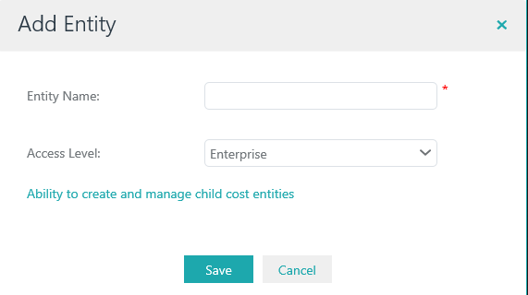

Entity Name: Enter an entity name to add multiple accounts of different clouds.

Access Level: It Provides access to the user for all reports. By default, it has ‘Enterprise’ selected which provides the ability to create and manage child entities.

When you select add new account, the pop up box below will appear and request you add below fields.

